GREEDY GRAPH ALGORITHM
- Office cabling prim’s MST
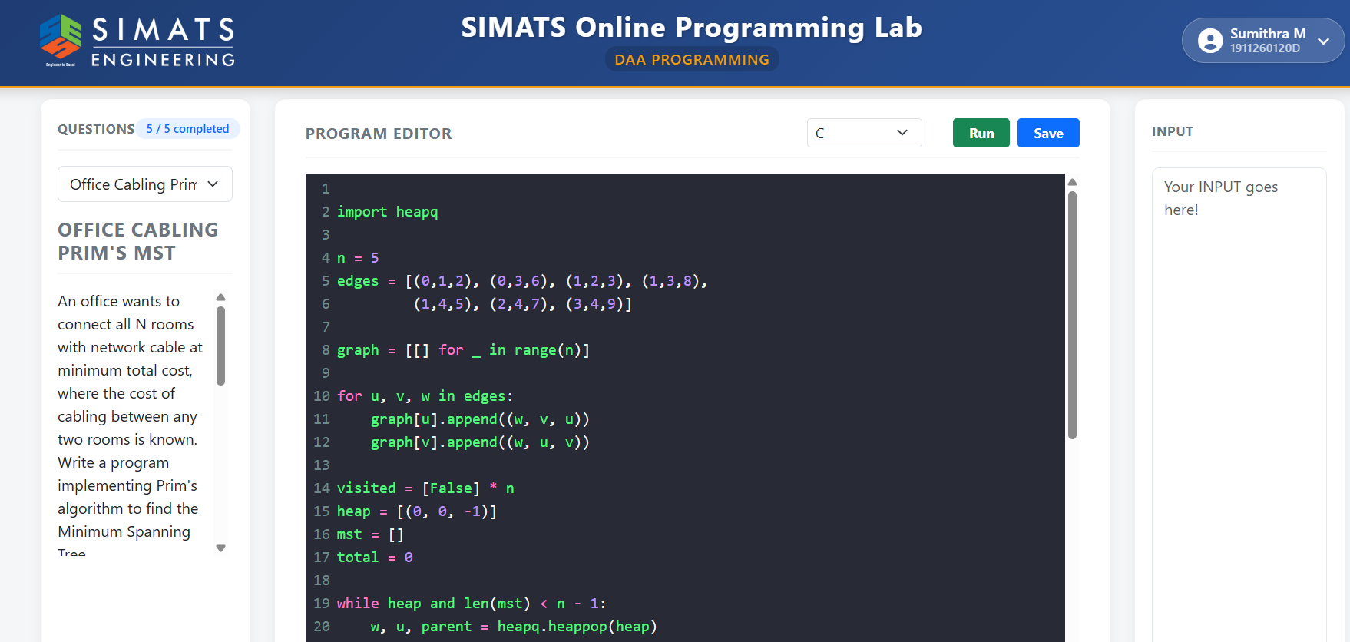
- Road network kruskal’s MST
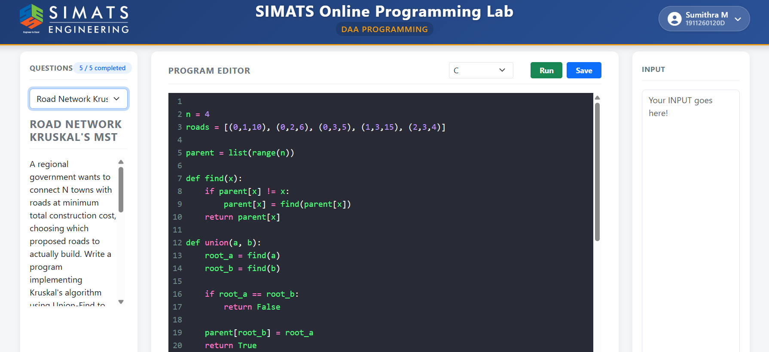
- GPS shortest route Dijkstra
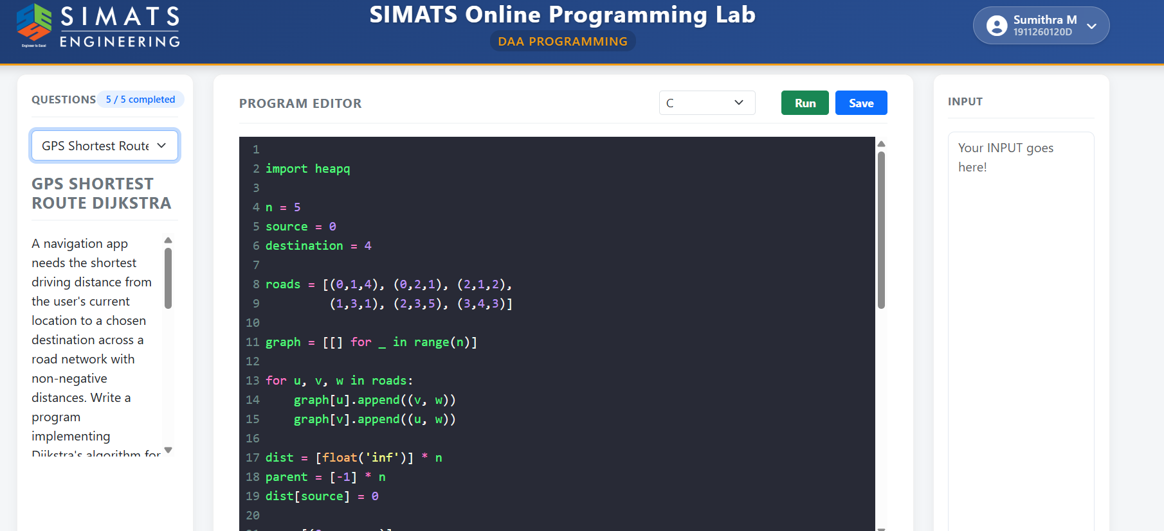
- Hub airport distances
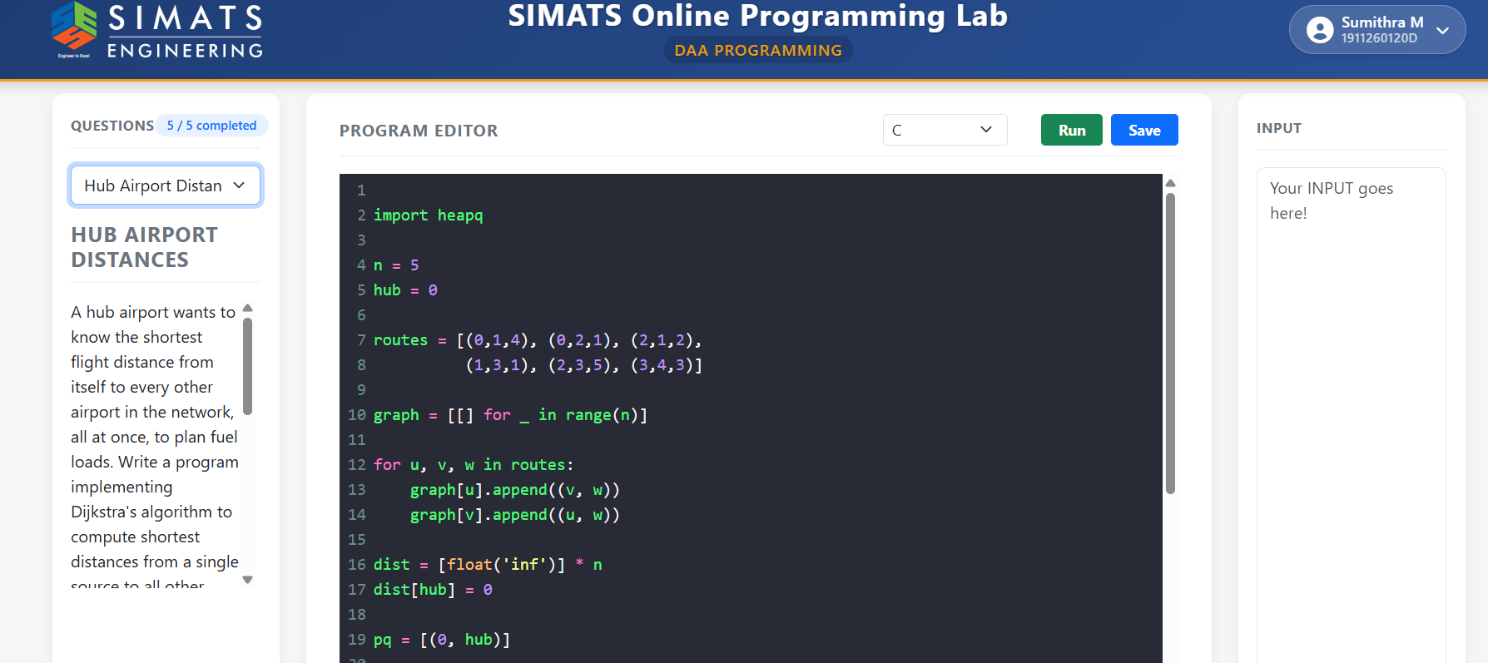
- Sensor network minimum wiring


